-EXPT NO:7 | IMPLEMENT ADVANCED CHART TYPES USING TABLEAU AND  POWER BI
DATE: 14.08.2026 | IMPLEMENT ADVANCED CHART TYPES USING TABLEAU AND  POWER BI
Roll: 24BAD071

PRE-LAB QUESTIONS (PROVIDE BRIEF ANSWERS TO THE FOLLOWING QUESTIONS)
IN-LAB EXERCISE:

1. What is data integration in the context of Business Intelligence (BI)?
Answer:
Data integration is the process of combining data from different sources into a single, unified view.
In BI, it allows organizations to collect data from databases, spreadsheets, cloud applications, and other systems.
This integrated data can then be analyzed to generate meaningful reports and support better decision-making.
2. Explain the difference between a join and a data blend in Tableau.
Answer:
A join combines tables using a common field before or during data analysis, usually within the same data source.
A data blend combines data from two different data sources using a shared field.
Joins work at the row level, while blending typically combines aggregated results from separate sources.
3. What are relationships and cardinality (e.g., one-to-many, many-to-many) in Power BI's data model?
Answer:
Relationships define how tables in Power BI are connected using common columns or keys.
Cardinality describes how many records in one table can relate to records in another table.
For example, in a one-to-many relationship, one customer can have many orders.
Many-to-many relationships allow multiple records on both sides to be related.
4. Why is data quality (e.g., consistent naming conventions, data types) crucial when integrating data from different sources?
Answer:
Good data quality ensures that information from different sources can be combined accurately and consistently.
Consistent names, formats, and data types help prevent errors, duplicates, and mismatched records.
Poor-quality data can lead to incorrect analysis, misleading reports, and poor business decisions.
5. Name two common challenges encountered during data integration.
Answer:
Two common challenges are inconsistent data formats and duplicate or missing data.
Different systems may store the same information using different names, formats, or data types.
Handling these differences requires data cleaning and transformation before the data can be integrated effectively.

OBJECTIVE:
To connect, combine, and model data from multiple sources in Tableau and Power BI and create a unified, comprehensive dashboard for holistic analysis.

PROCEDURE:
- Data Collection:
  - Import two datasets:
    - Dataset 1: Sales Data (CSV) → Order ID, Order Date, Region, Sales Amount
    - Dataset 2: Regional Sales Targets (Excel) → Region, Sales Target, Target Year
- Data Preparation and Transformation:
  - Clean datasets (e.g., standardize "N. America" → "North America"). • Ensure correct data types (numeric for Sales, date for Order Date).
  - Handle missing values appropriately.
- Data Integration and Modeling:
  - Tableau: Create a join/relationship on the Region field in the Data Source pane.
  - Power BI: Use the Model view to create a relationship on Region; define cardinality (e.g., many-to-one).
- Create Calculated Fields for Comparison:
  - Target Achievement % = (SUM(Sales) / SUM(Sales Target)) * 100
  - Sales vs. Target Variance = SUM(Sales) - SUM(Sales Target)
- Design a Comprehensive Dashboard:
  - Combine visuals from both sources.
  - Add KPI cards: Total Sales, Overall Target Achievement %.
  - Use gauge/bullet charts for region-wise target performance.
  - Combined bar chart: Actual Sales vs. Target by Region.
  - Map visualization: Sales vs. Target Variance by region.
- Validate Data Integrity:
  - Cross-check joined data for accuracy.
  - Ensure dashboard filters correctly update visuals.
- Publishing and Sharing:
  - Tableau: Publish to Tableau Public or Server.
  - Power BI: Publish to Power BI Service and share.
Experiment Datasets:
  - Dataset 1: Retail Sales Data (CSV) → Order ID, Order Date, Region, Sales
  - Dataset 2: Regional Sales Targets (Excel) → Region, Sales Target, Target Year

Tableau:

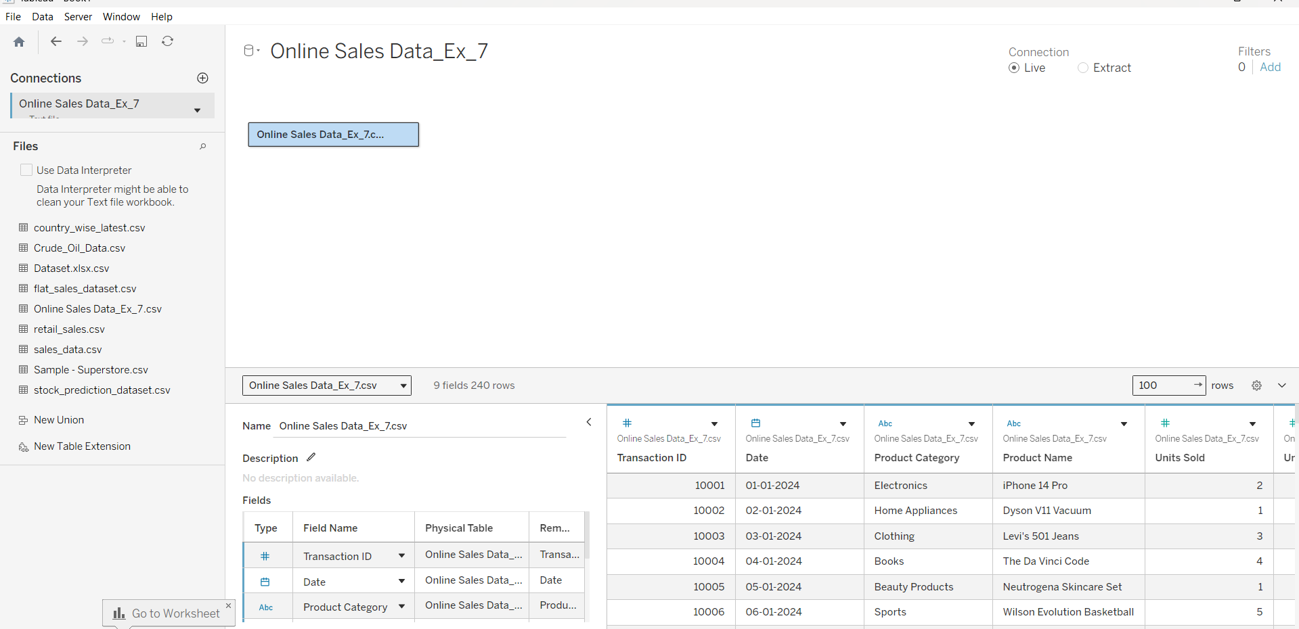
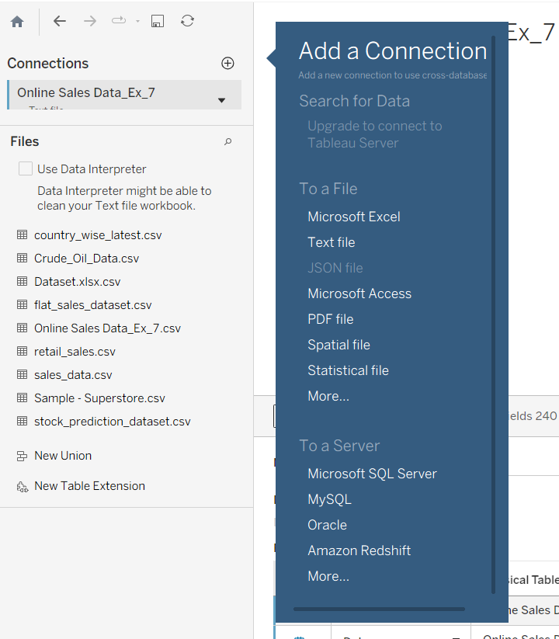

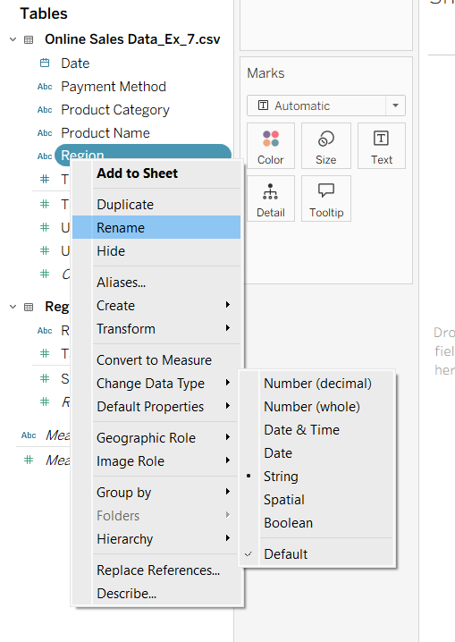
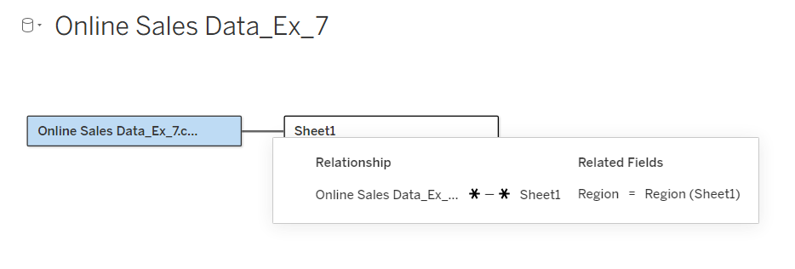

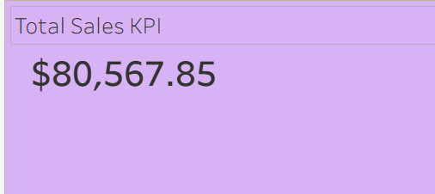

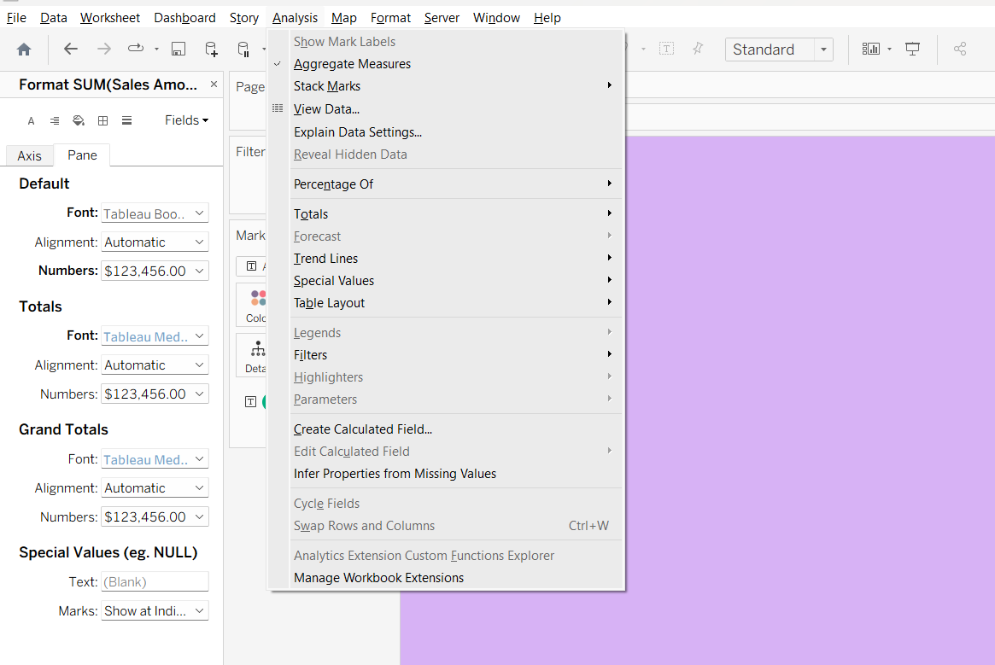
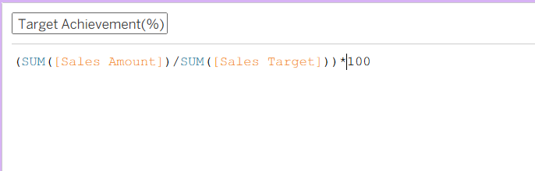
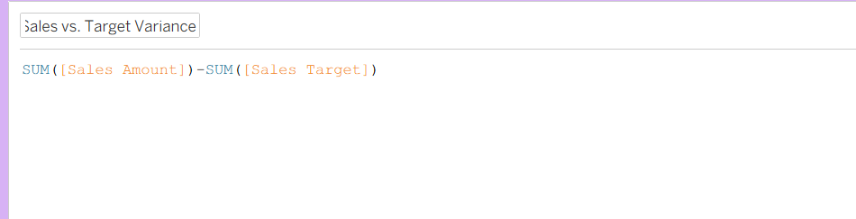

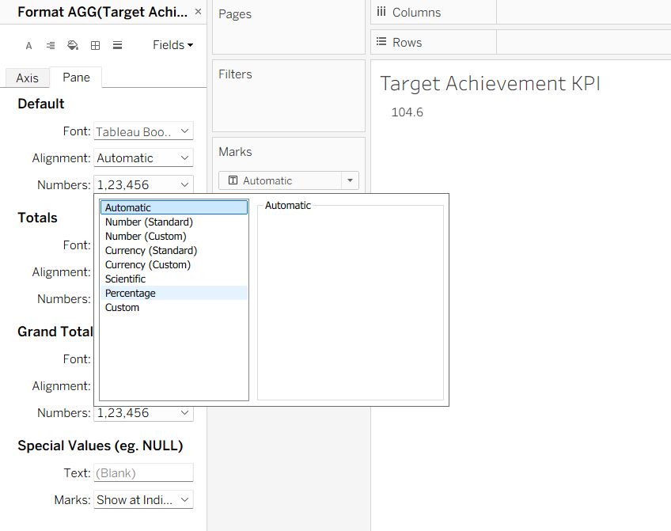

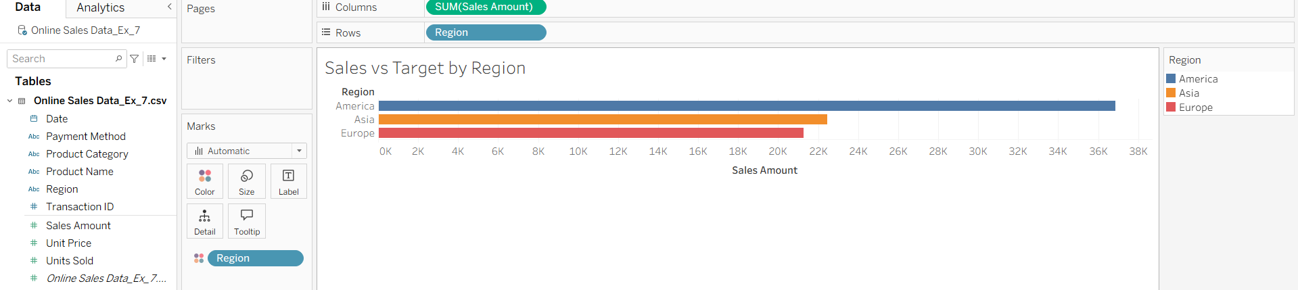

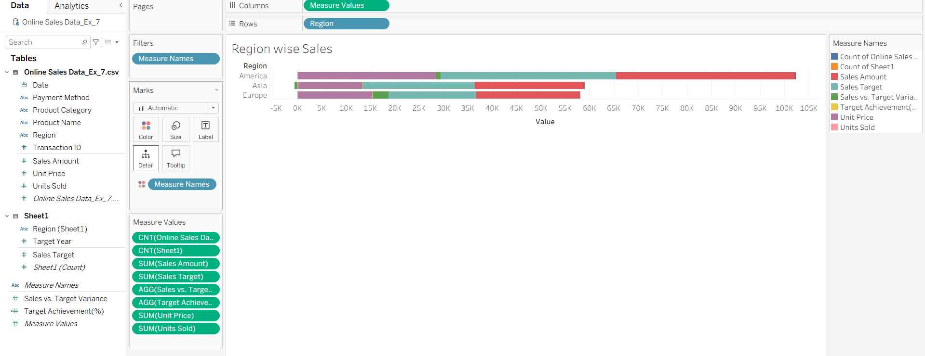

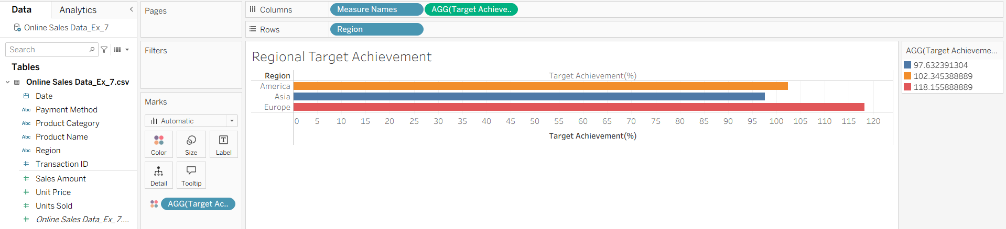

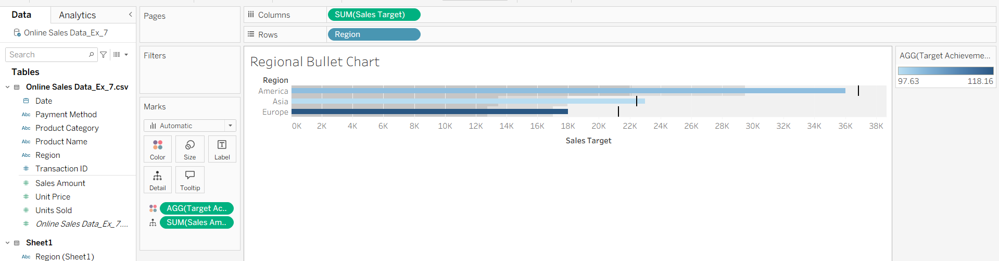

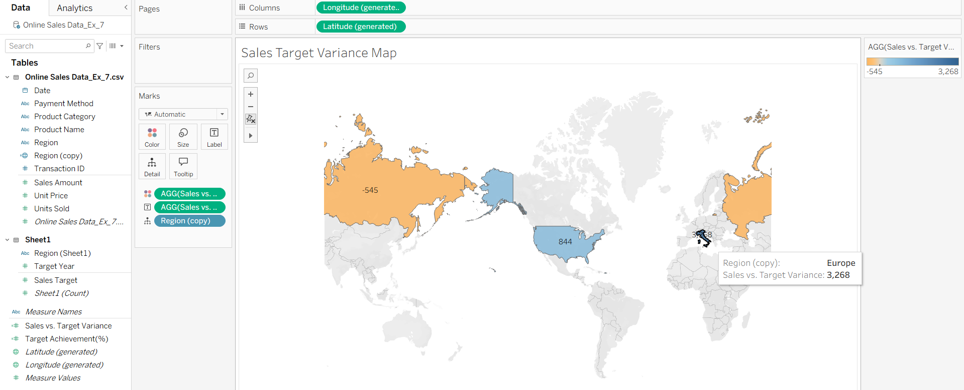

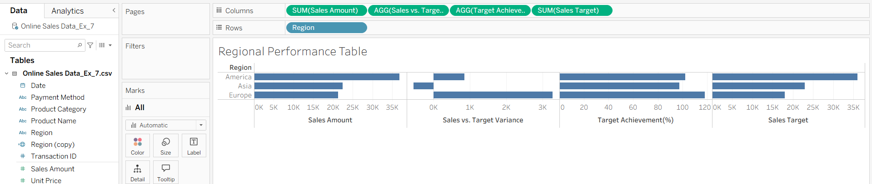

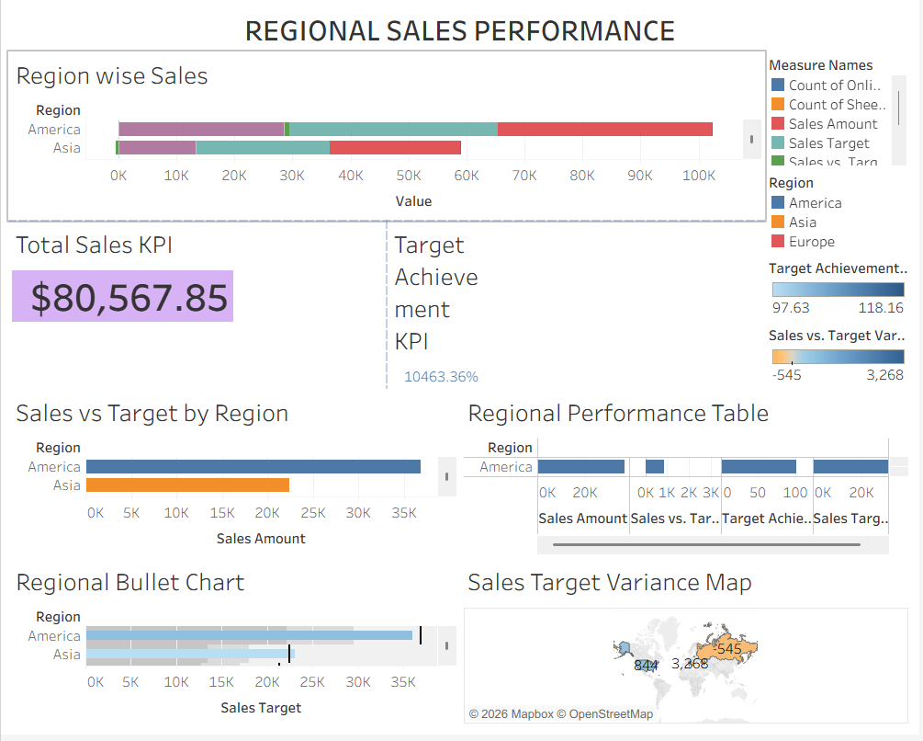

Power BI:
https://app.powerbi.com/groups/me/reports/9a4ffd07-2ba4-428a-a450-94682d9ef888/de69096f3a6953805baa?experience=power-bi
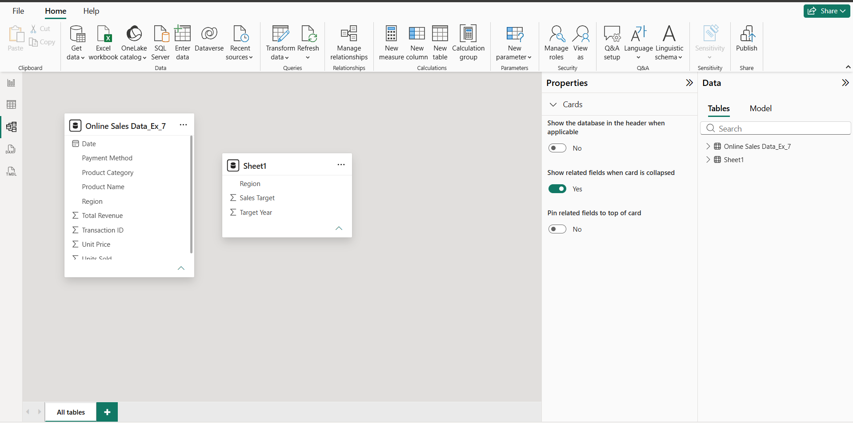

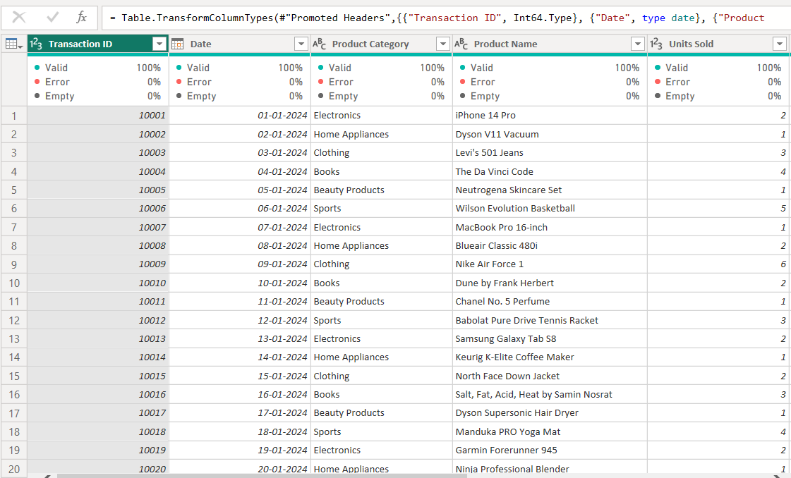

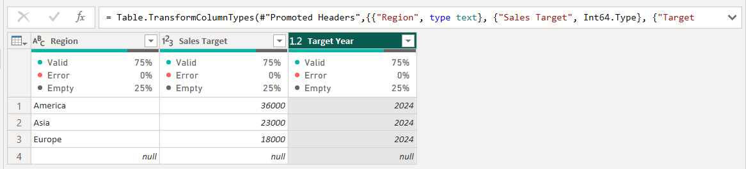

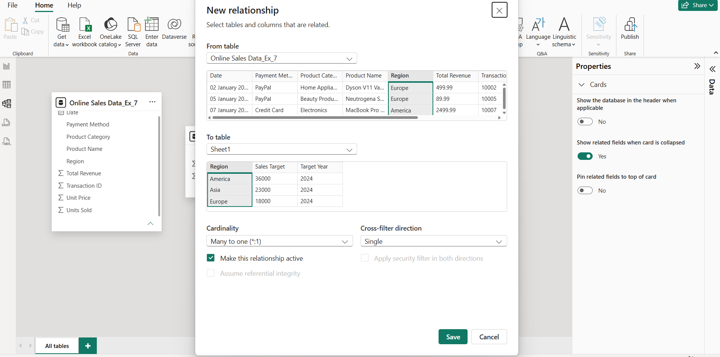

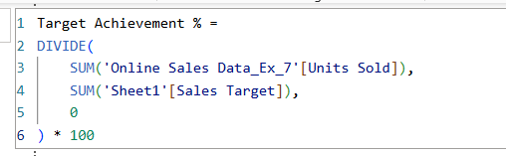

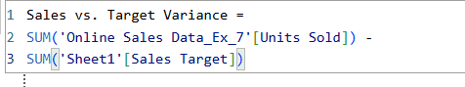

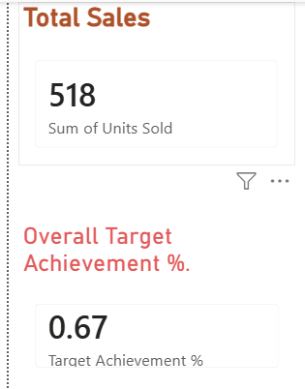

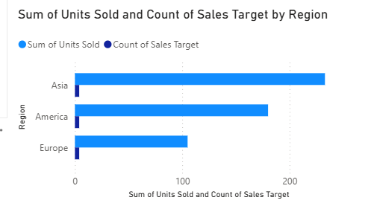

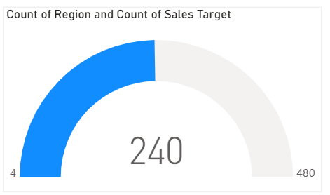
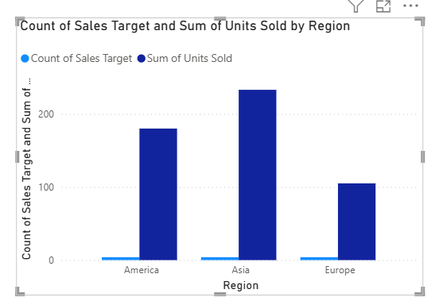

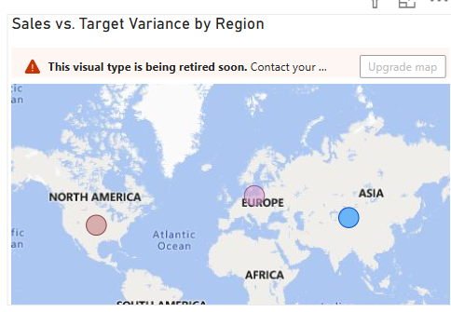
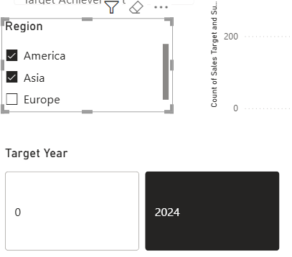

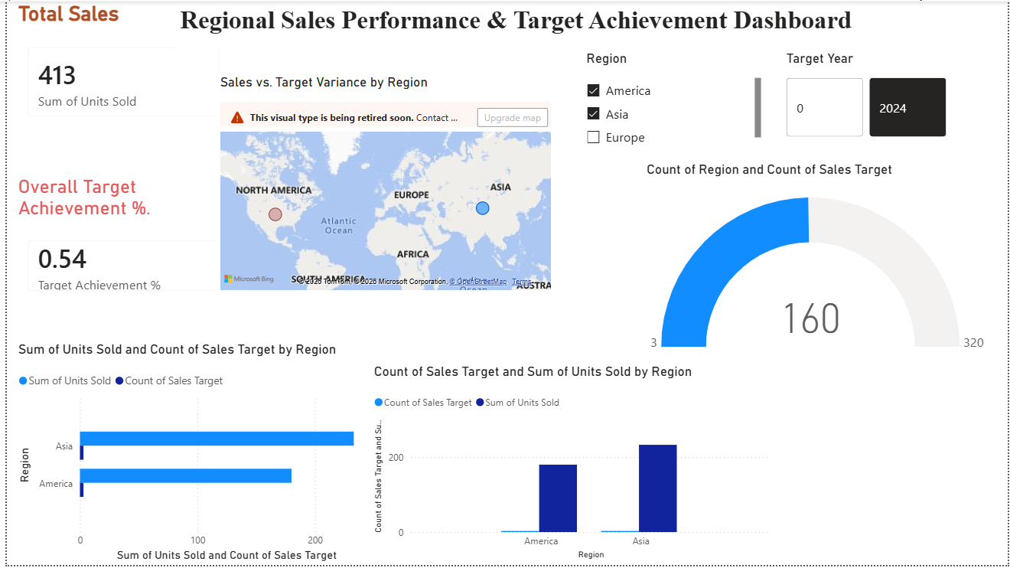

POST-LAB QUESTIONS (PROVIDE BRIEF ANSWERS TO THE FOLLOWING QUESTIONS)

- How did integrating the sales targets data provide a more complete analytical picture than using the sales data alone?
• Integrating sales targets allowed us to compare actual sales with planned targets.
• It helped identify regions that were meeting, exceeding, or falling below their targets.
• The dashboard could show KPIs such as Target Achievement % and Sales vs. Target Variance.
• This provided better insights for performance evaluation and business decision-making.

- Describe the type of join or relationship you used to combine the two datasets and explain why it was the appropriate choice.
• The two datasets were combined using the Region field as the common key.
• In Tableau, a join/relationship was created between the Sales and Regional Sales Targets data.
• In Power BI, a many-to-one relationship was appropriate because many sales records can belong to one regional target.
• This allowed actual sales to be compared with the corresponding target for each region.

- What challenges, if any, did you face regarding data granularity or mismatched keys (e.g., different region names) between the two sources?
• A major challenge was ensuring that region names were consistent across both datasets.
• For example, "N. America" had to be standardized to "North America".
• There could also be differences in data granularity because sales data contains individual orders, while target data contains regional targets.
• These issues were handled through data cleaning, transformation, and validation before integration.

- How can creating variance calculations (e.g., Sales vs. Target) help a business manager make better decisions?
• Sales vs. Target Variance shows whether actual sales are above or below the planned target.
• Positive variance indicates that a region is performing above expectations, while negative variance highlights underperformance.
• Managers can use this information to identify areas needing improvement or additional resources.
• It supports better decisions about sales strategies, budgets, and resource allocation.

- What other data source (e.g., marketing campaign data, customer demographics) could you integrate to further enrich this analysis, and what new insights might it provide?
• Marketing campaign data could be integrated with the sales and target datasets.
• It could help determine whether marketing campaigns contributed to increased sales in specific regions.
• Managers could compare campaign spending, customer responses, and sales performance.
• This would provide insights into marketing effectiveness and return on investment (ROI).
RESULT:

The retail sales and regional targets datasets were successfully connected, cleaned, and integrated in Tableau and Power BI. Relationships between the sources created a unified data model. The dashboard visualized sales performance against targets, enabling variance analysis and providing insights into regional performance not possible with a single data source.

ASSESSMENT

Description |  | Max Marks | Marks Awarded
Pre Lab Exercise |  | 5
In Lab Exercise |  | 10
Post Lab Exercise |  | 5
Viva |  | 10
 | Total | 30
 | Faculty Signature

